**CHAPTER 3**

**HIGH LEVEL DESIGN**

* 1. **DESIGN CONSIDERATIONS**
     1. **Assumptions and Dependencies**

The following assumptions and dependencies have been considered while designing the software :

* There is an available LAN connection and all the systems and printers are connected to the same network via LAN cables.
* The server computer is on and working when the print job is given.
* The printer drivers are installed before a print is given to it.
* Any new printer/user is added by the administrator to the database before they give their print jobs.
* Preferably, a single user is associated with a single computer.
* A user is always connected to the network to verify his/her login details.
  + 1. **Goals and Constraints**

The following goals are being achieved :

* The print job given by any user is being recorded properly and stored in the database.
* User quota is checked before printing any document and updated after printing for next use.
* The server database is up to date all the time.
* Appropriate error messages displayed when necessary.

The constraints include :

* An administrator to add/delete any user/printer to the database and provide the user with the login credentials.
* LAN connectivity at all times with lan cables for each printer and system.
  1. **SYSTEM ARCHITECTURE**

The architecture of the system includes a LAN network with various number of systems each running our client software, a server system running the administrator software and network printers connected via LAN cables.

A print job is given from any client machine to any of the printers on the network, quota checked, if successful, document printed and job details updated to the database. The information can be viewed by the administrator at a later stage.

The following diagram shows the system architecture :

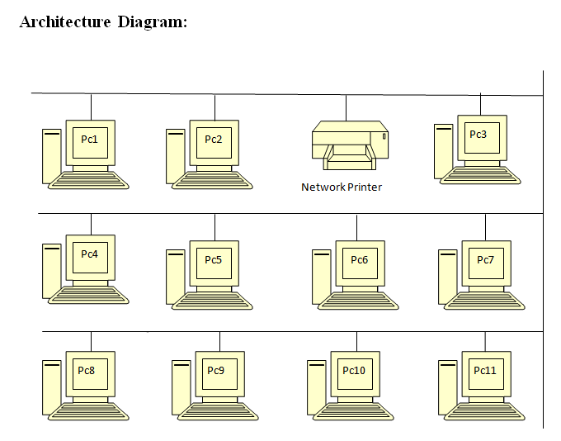

**Figure 3.1 system architecture**

* 1. **DATA FLOW DIAGRAM**

This project uses two level hierarchy model. Two level hierarchy model comprises of local database on each client machine and the main administrator database server. The local database stores the print job details in the form of an xml document and then updated to the mysql database when a connection is established. The main databse information can be viewed periodically.

The following figure shows the data flow diagram :

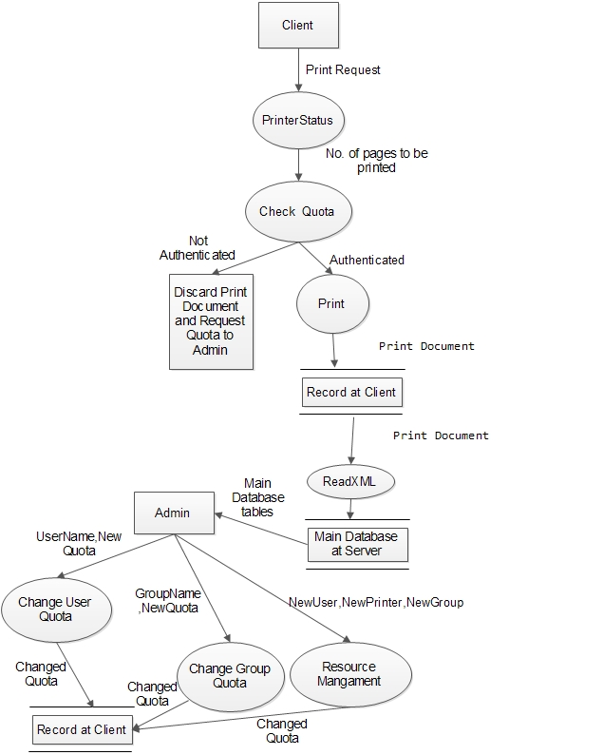

**Figure 3.2 Data flow diagram**

The above diagram represents the following: When a user gives a print request, the print job is paused along with the print queue. The number of pages to be printed is calculated by the windows service, Printer Status, and the quota for the user is checked with the total number of pages to be printed. If quota is available, the document is printed else it is discarded and an message to request for more quota is displayed.

Once the document is printed, all the related information for that job is recorded on the local database and the quota updated for the user. The second windows service, ReadXML, reads the xml document and updates it to the main database and deletes that entry from the local database.

The administrator can view information of all users, printers and the print jobs with respect to a user or printer stored the main database. He/she can also add/delete users/printers. Can also create new groups, assign users/printers to it and change group quota. The user quota can be changed on request by the user.

* 1. **FUNCTIONALITY OF THE SYSTEM**

The following functionalities are included in the system :

* User and administrator authentication
* Advanced filtering and restrictions for each user
* Track multiple local and network printers
* Update main database and user quota
* Track all the user connected to the LAN
* Customizable report generation
* Pop-ups and alerts
  1. **ENTITY RELATIONSHIP DIAGRAM**

The following diagram shows the various tables in the main database and the relationships between them.

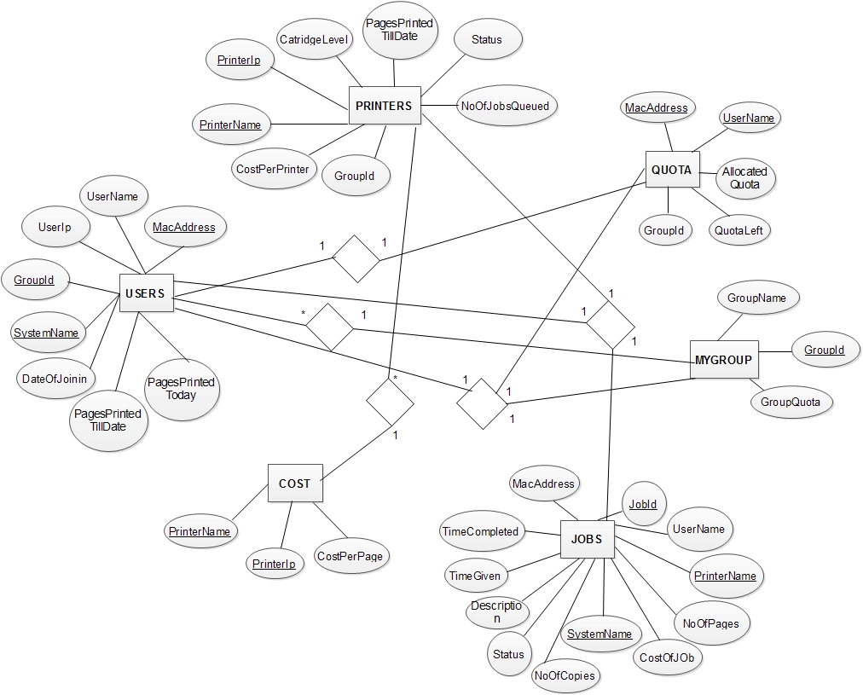

**Figure 3.3 Entity Relationship Diagram**

Each database will be based on the organization name and created in the administrator

system. It will consist of six tables :

* Users – It stores all the user specific information such as the MAC address, UserName etc.
* Printers – It stores all the printer related information such as printer name, IP address of the printer etc.
* Mygroup – This table is made to store the groups/departments in the organization. A user/printer is related with the help of the group id of the group.
* Quota – Quota table stores the user quota details such as the allocated quota, quota left etc.
* Cost – the cost table is required to calculate the cost of each print job. It stores the cost per page for each printer.
  1. **USE CASE DIAGRAMS**
     1. **User ( Client )**

The following diagram shows the functionalities for any user using the client software.

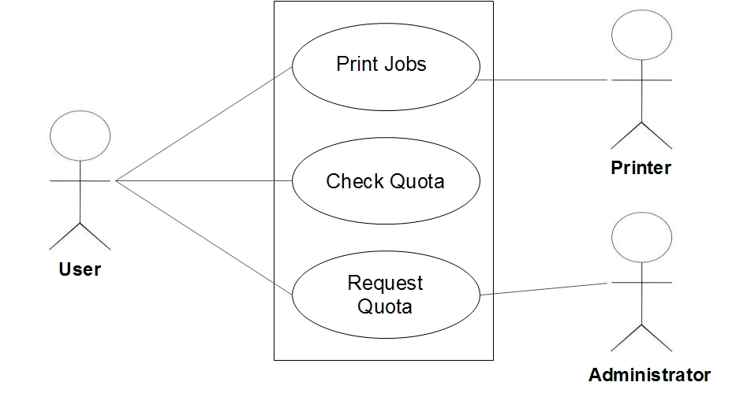

**Figure 3.4 Use Case Diagram for User**

The functionalities of the user includes : Printing jobs, Checking his/her quota and sending quota requests to administrator on completion of the quota for more quota to allocated. All the functionalities can be used through an easy to use client user interface provided by the software.

* + 1. **Administrator ( Server )**

The following diagram shows the functionalities for the administrator of the organization using the administrator software.

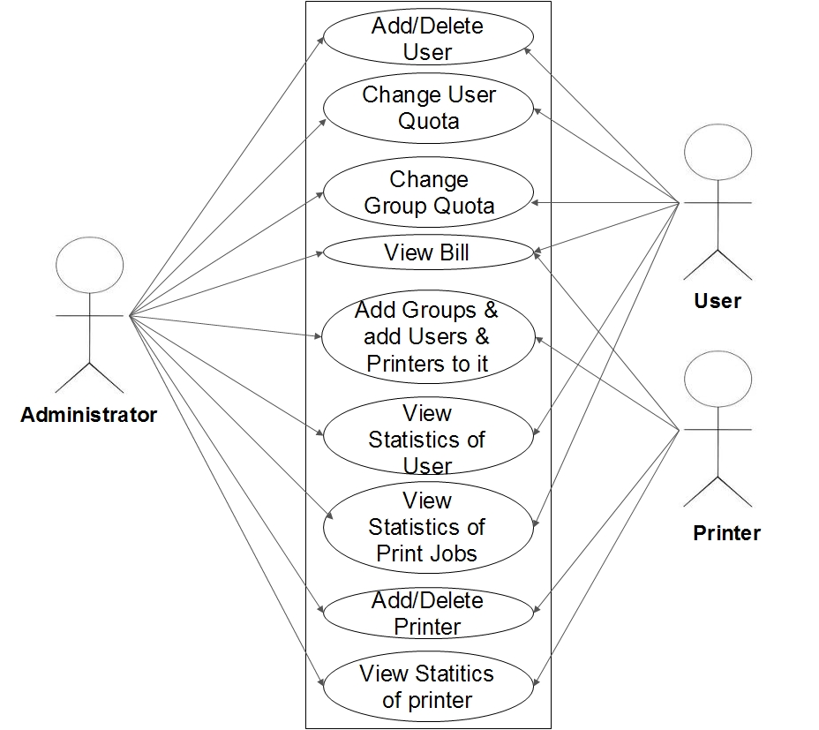

**Figure 3.5 Use Case Diagram for Administrator**

The functionalities of the administrator include :

* View information about user/printer.
* View statistics of print jobs.
* Add/delete a user/printer.
* Add/delete groups/departments.
* Add/remove/modify a user’s/printer’s group.
* Change user and group quota.

All the functionalities can be used through an easy to use administrator user interface provided by the software.

* 1. **SUMMARY**

This chapter includes the high level design of the developed software. It includes the goals achieved and also mentions few of the constraints that are a part of the software. It then includes the overall architecture of the system and a brief description on it. Then comes the database organization required for the software and the use case diagrams for the user and the administrator. It also describes the user specific functionality and their interaction with other components of the system.